**Assignment – 12**

Name- Yashraj Ranjeet Shitole

Roll no. - 86633

1) Write a query that selects all customers whose ratings are equal to or greater than ANY of Serres’.

**select * from customers where rating >=any (select rating from customers,salespeople where customers.snum = salespeople.snum and sname='Serres');**

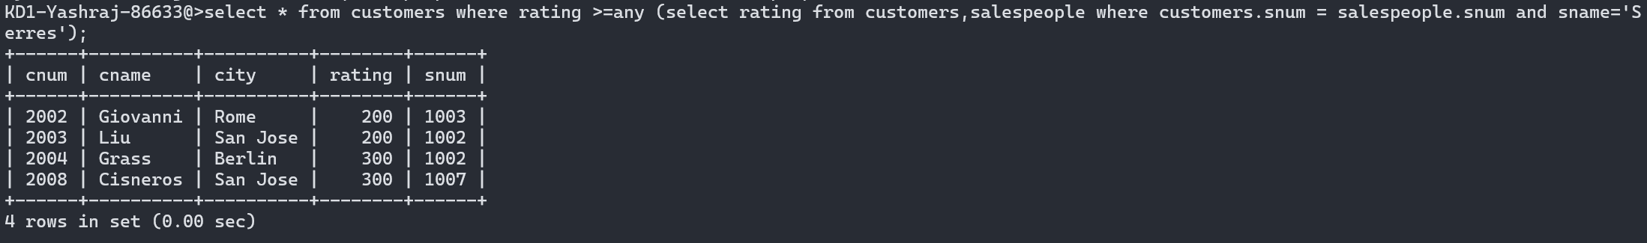

2) Write a query using ANY or ALL that will find all salespeople who have no customers located in their city.

**SELECT sname from salespeople, customer where salespeople.city not in (select city from customers) and salespeople.snum=orders.snum;**

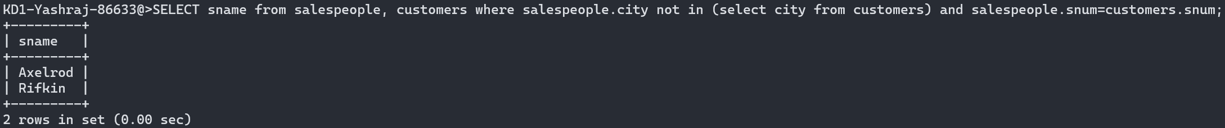

3) Write a query that selects all orders for amounts greater than any for the customers in London.

**SELECT * from orders where amt > any (select amt from orders,customers where customers.cnum = orders.cnum and customers.city='London');**

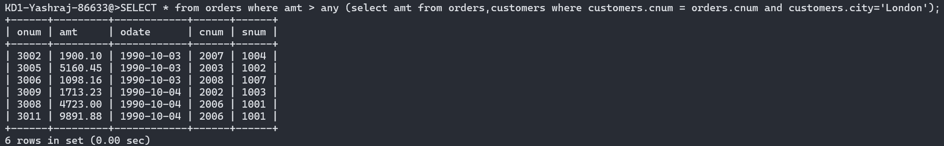

4) Write the above query using MIN or MAX.

**SELECT * from orders where amt > (select min(amt) from orders,customers where customers.cnum = orders.cnum and customers.city='London');**

